Data Visualization by Tableau

Udit Manish Parekh

Installation of Tableau

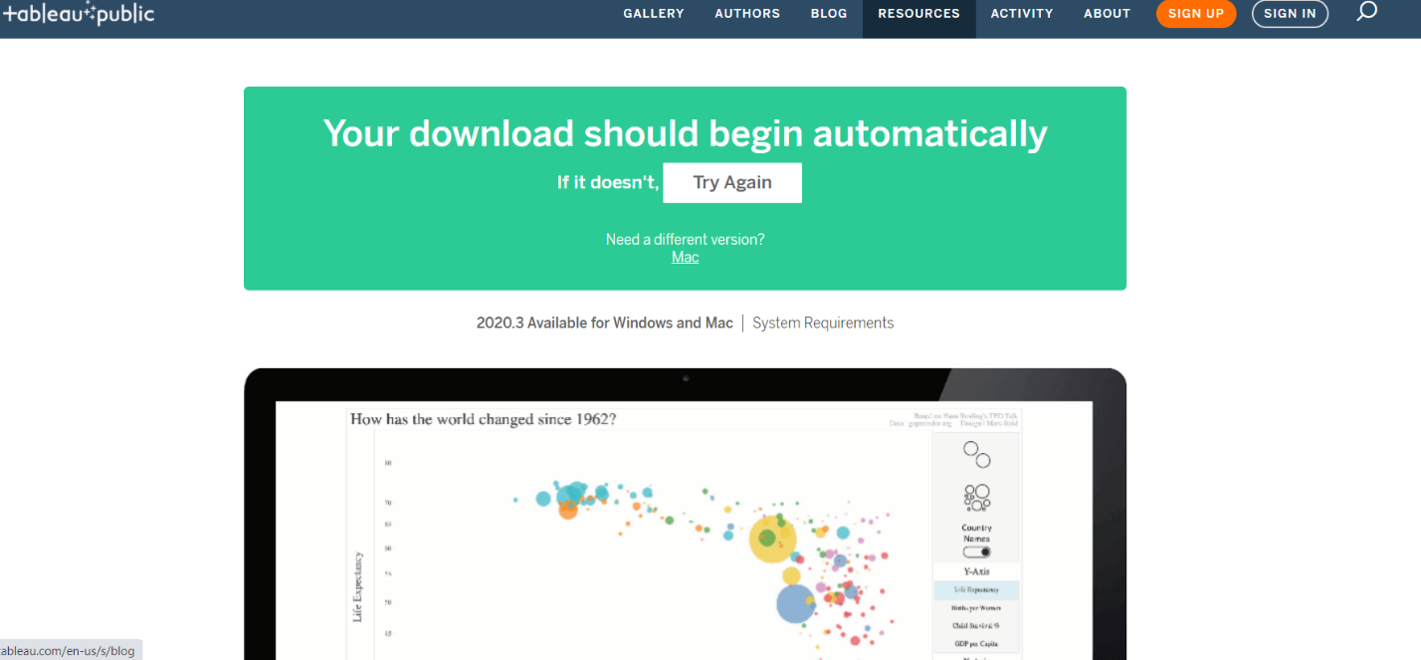

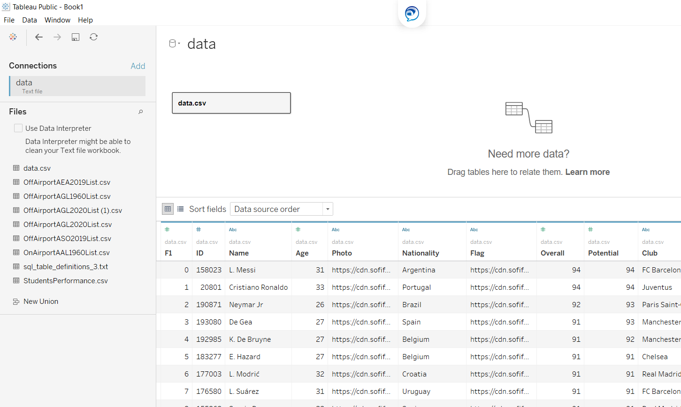

FIFA 19: A Data Visualization project with Tableau

FIFA 19 is popular soccer video game among many countries. Each year EA sports launches new FIFA video games for fans around the world. Each Game is different from previous year consisting from Players Stats, Ranking, and Potential of each year. This project is find out highest number of players with highest stats among top 20 countries in FIFA 19. For this Study the data sets were downloaded from Kaggle.com at <https://www.kaggle.com/karangadiya/fifa19>. The choice of the dataset was based on the purpose of investigating the highest number of stats of a player consist of International ranking, Overall rating and Overall Potential rating giver in Fifa 19 including the national ranking.

**ADDING DATA SETS**

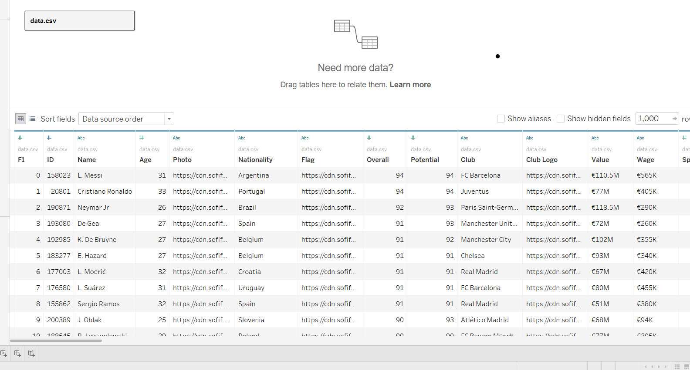

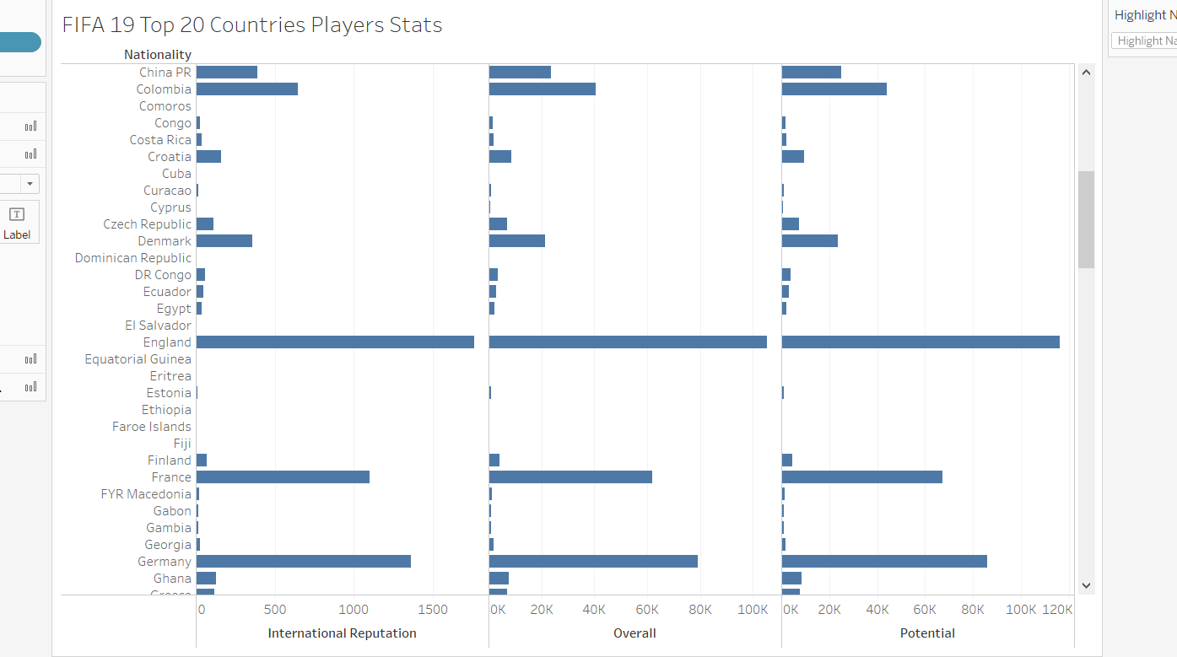

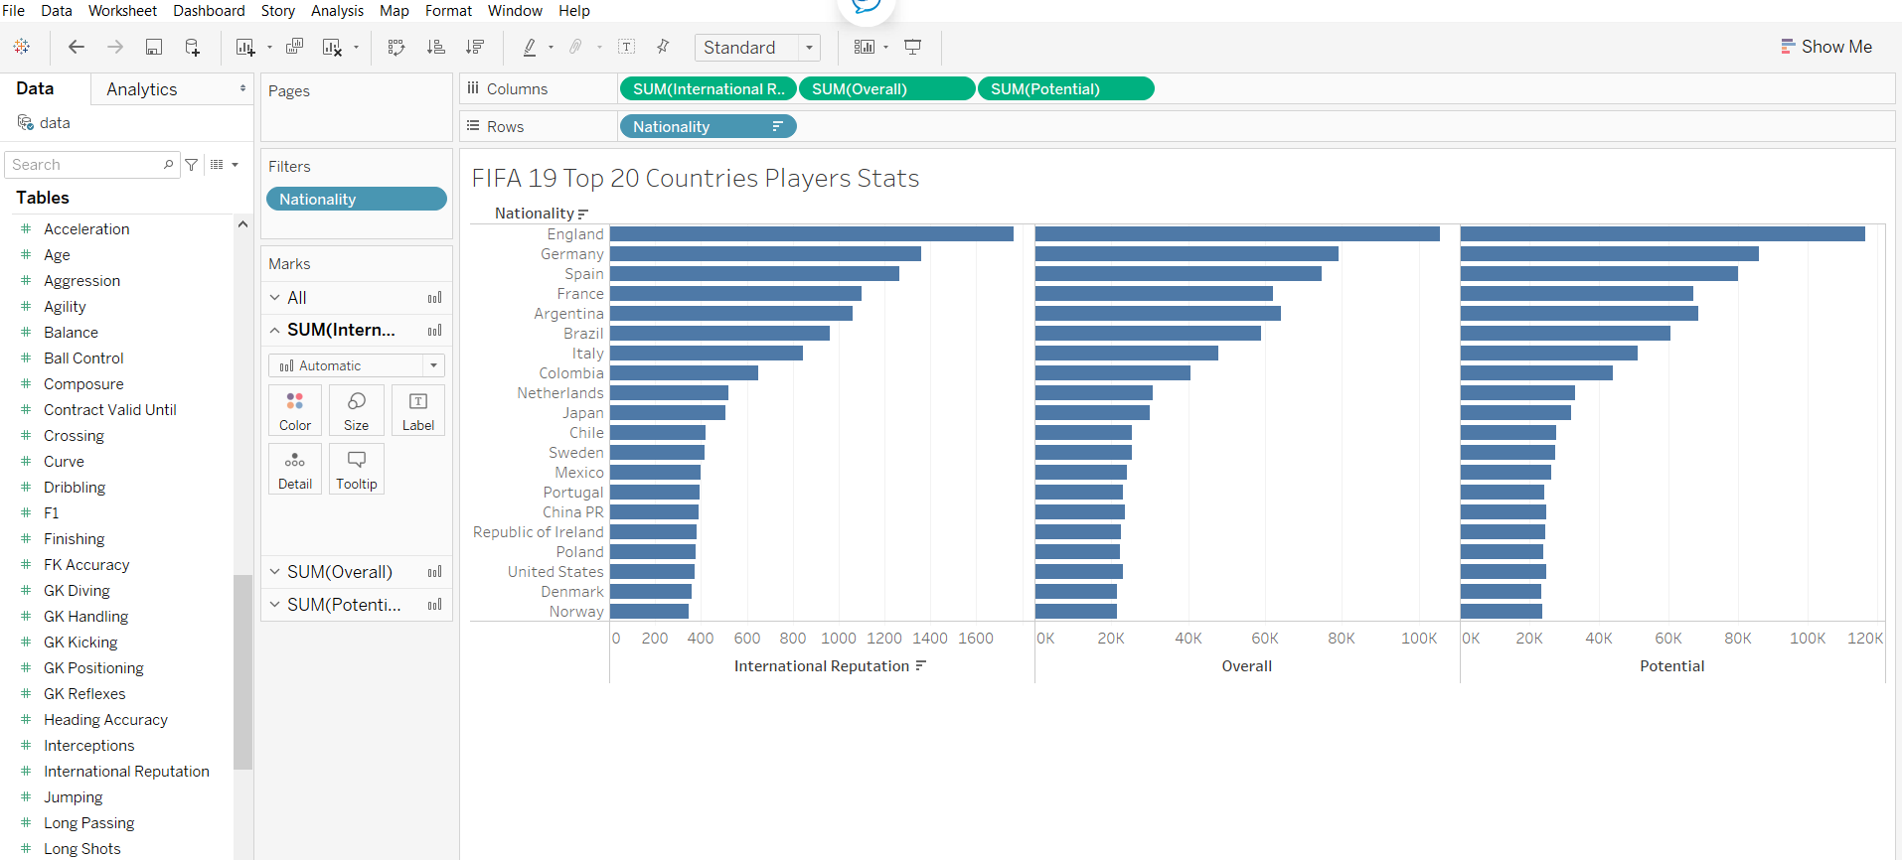

The above Chart comprises from 18,208 players stats and attributes categorized by Nationality. The Key Columns from the Data sets are Name: Tell the name of Football Players from different continent & nationalities, Overall, Potential: The way a player conditions, trains all contribute to his overall performance. The player is rated over 0 to 100 scale, Skill Moves, International Ranking, Preferred Foot: Players are ranked on the level of skills they have on the scale of 1 to 5. Out of this Players stats and attributes, the data sets are further filtered by top 20 countries.

The visualization of the data sets meets the criteria of Trustworthy as the above chart visualization of data are derived from complete data sets with accurate numbers categorized by Nationality of each players. You can see the top 20 countries and England has most players with highest Overall, Potential and Ranking whereas Norway has least. The Accessibility of the data focuses on relevant content. From the data set there are number of columns but the chart focuses towards the main objective of the project and highlighting key columns from the data set. The visualization also meet the Elegance criteria, as it is simple chart, which is easy to read and understand.

**References**

Hardin, M., Hom, D., Perez, R., & Williams, L. (2012). Which chart or graph is right for you?. *Tell Impactful Stories with Data. Tableau Software*.

Kirk, A. (2016). *Data visualisation: A handbook for data driven design*. Sage.